Issue: March 2018
Scotch® 399 Duct Tape
Description
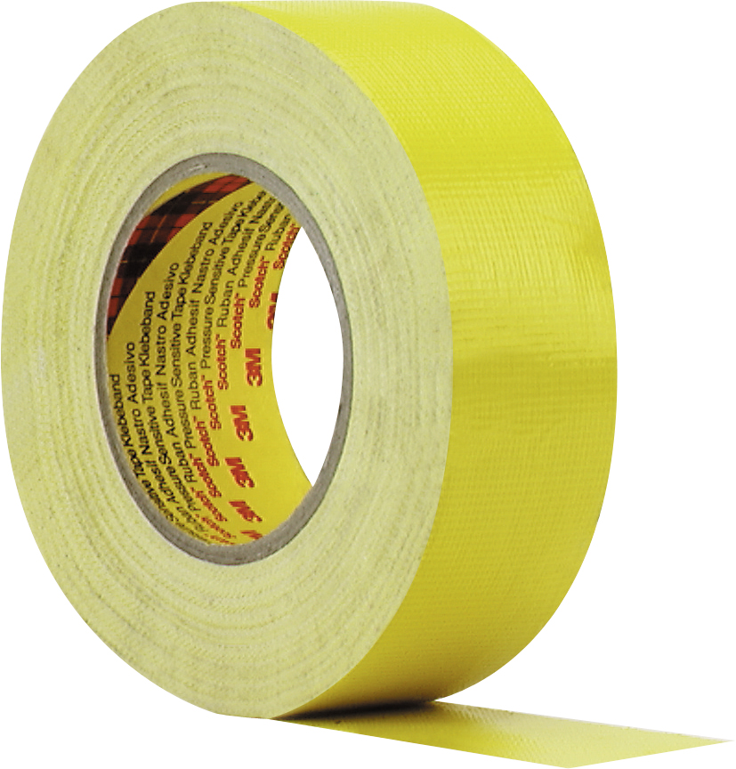
Scotch® 399 is a conformable, highly adhesive duct tape for extreme loads. Tear and waterproof. Ideal for outdoor use, for masking rough surfaces such as concrete, stone and bricks during plastering or high-pressure cleaning. Up to 2 weeks UV-resistant.
Product Characteristics
Backing | Polyethylene coated fabric
Adhesive | Rubber-based adhesive
Standard Roll length | 50 m
Color | Yellow

Typical Physical Properties | value | Method
Total thickness | 220 µm | AFERA 5006
Adhesion to steel | 5 N/cm | AFERA 5001
Tensile strength | 35 N/cm | AFERA 5004
Elongation at break | 20 % | AFERA 5004
The values displayed are the result of illustrative lab test measures made according to the indicated external norm and shall not be considered as a commitment from 3M

Storage
To obtain best performances, store this product under normal condition of 18°C and 60% relative humidity in the original packaging and use it within one year from date of purchase.
Warning
Surfaces should be clean: free of dust, grease, oil and release agents
Surfaces should be dry and solid
In case of doubt, test before use

Features/Advantages/Benefits
Features | Advantages | Benefits
Rubber adhesive | Instant adhesion | Stick easily to the surface
 | Good holding power | Helps resist lifting or curling, Helps reduce work
PE backing | Good unwinding, easy tear by hand | Easy handling
 | Conformability | Improved Sealing
Backing saturant | Moisture resistant

Important notice:
The use of the 3M product described within this document assumes that the user has read and understood the user notice. Before any use of this product it is recommended to complete some trials to validate the performance of the product within its expected purpose.
All information and specification details contained within this document are inherent to this specific 3M product and would not be applied to other products or environment. Any action or usage of this product made in violation of this document is at the risk of the user.
Compliance to the information and specification relative to the 3M product contained within this document does not exempt the user from compliance with additional guidelines (safety rules, procedures). Compliance to operational requirements especially in respect to the environment and usage of tools with this product must be observed. The 3M group (which cannot verify or control those elements) would not be held responsible for the consequences of any violation of these rules which remain external to its decision and control.
Warranty conditions for 3M products are determined with the sales contract documents and with the mandatory and applicable clause, excluding any other warranty or compensation

